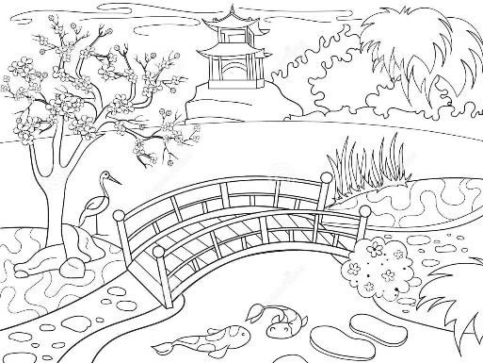
Welcome to our garden!
に | わ | に | よ | う | こ | そ | ！

Your task is to create a spiel about your garden to try and entice people to vote for your garden design in the competition.
Welcome people to your garden and then tell them about at least 3 elements in your garden. For example:
Welcome to our garden! There is a beautiful lake. There is a bridge. It’s old. There are big cherry trees. The garden is quiet.
Attractions/Places in Gardens |  |  | Adjectives (なtype adjectives are shaded)
にわ | Garden |  | 小さい | Small
はし | Bridge |  | 大きい | Big
いけ | Lake |  | ふるい | Old
木 | Tree |  | あたらしい | New
さくら | Cherry blossoms |  | うつくしい | Beautiful
いし | Rocks |  | たのしい | Fun/Enjoyable
かれさんすい | Sand garden |  | おもしろい | Interesting
とびいし | Stepping stones |  | しずか | Quiet
とうろう | Lantern |  | きれい | Pretty/clean
もん | Gate |  | ゆうめい | Famous
たけ | Bamboo |  | にぎやか | Noisy, busy, bustling

Sentence Structures
Use these sentences to write a description about each of your 3 places.

Option 1 – Use 2 sentences
element | が | あ | り | ま | す | 。
There is a ＿＿＿＿.
adjective | で | す | 。
It’s ＿＿＿＿＿＿.

Option 2 – Use 1 sentence
なadjective | な | element | が | あ | り | ま | す | 。
いadjective | element | が | あ | り | ま | す | 。
There is a ＿＿＿＿＿ ＿＿＿＿＿.

If you want to just describe something, use this sentence pattern.
element | は
adjective | で | す | 。
________ is _____________.

Choose 3 elements in your garden and at least 1 adjective for each. Write them in English in this table.

 | 1 | 2 | 3
Element

Adjective

Write your paragraph here in English and below in Japanese.
____________________________________________________________________________________________________________________________________________________________________________________________________________________________________________________________________________________________________________________________________________________________________________________________________________________________________________________________________________________________________________

