The Ainu
Watch this video from the 5:48 minute mark through to the 9:02 minute mark.
Then answer the following questions.
Video link: https://www.youtube.com/watch?v=5tnK2FK2298
1. Unjumble these letters to write the kind of lifestyle that the Ainu traditionally lived.
R | N | U | T | H | E |  | R | H | T | E | E | R | A | G

Answer: ________________ ______________________
2. Match the correct animal to the time of year it was hunted with a line.
(One will have two animals linked)
All year round |  | Spring |  | Autumn

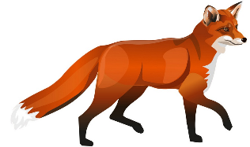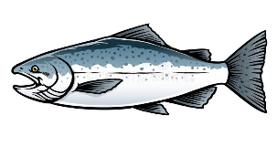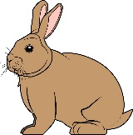
3. The clothing of the ainu were made using resources that were found in the forests or rivers.
Find the missing words for these sentences in the wordfind below and write them onto the lines in the correct spaces.
The fabric for their tunic was made from the ____________ of the ______ _________.
Shoes were made from the dried skins of _________ and ______________.
And the men wore head bands made from _____________ _____________.
V | I | N | E | A | B | C | B
D | R | G | R | A | P | E | A
S | A | L | M | O | N | F | R
E | H | O | F | R | U | T | K
E | L | M | D | A | R | Q | C
C | E | D | E | F | O | G | D
F | I | S | E | T | R | E | E
F | Y | H | R | P | H | B | X
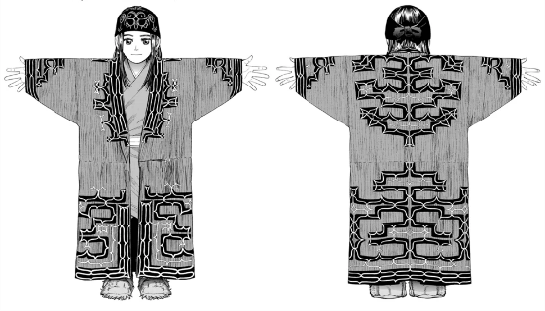

4. Ainu housing was made with the walls being insulated with bundles of thatch and a sunken fire pit in the middle. Decode the last piece of information using the letter codes below:
a | b | c | d | e | f | g | h | i | j | k | l | m | n | o | p | q | r | s | t | u | v | w | x | y | z
1 | 2 | 3 | 4 | 5 | 6 | 7 | 8 | 9 | 10 | 11 | 12 | 13 | 14 | 15 | 16 | 17 | 18 | 19 | 20 | 21 | 22 | 23 | 24 | 25 | 26

5 1 3 8 13 5 13 2 5 18 15 6 20 8 5 6 1 13 9 12 25 8 1 4
1 16 12 1 3 5 1 18 15 21 14 4 20 8 5 6 9 18 5

Answer: _______________________________________________________________________________

