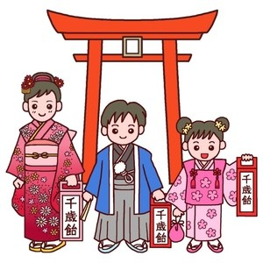
Japanese Children Celebrate
Shichi-go-san
In Japan, children dress up for a special ceremony called Shichi-go-san. At this festival, children are honored by their families and blessed at a Shinto shrine.
Shinto is a very old religion that many people in Japan still follow. The Shinto divine deities (kami) are found mostly in nature, such as in mountains, rivers, and the sky. The kami protect the Japanese people and guard the health of their children.
In this religion, people believe that ages three, five, and seven are important times of growth and health in a child’s life. They also believe that odd numbers, especially three, five, and seven, are lucky numbers. So children who live past these ages are thought to be lucky.
Long ago, Shichi-go-san was three different ceremonies that celebrated important times in a child’s life.
At the Rite of Kamioki, parents brought their three-year-old children to the local shrine to be blessed and to show that the babies had survived infancy. In those days, parents shaved their babies’ heads. The way people wore their hair showed which social class they belonged to. Shaved heads showed that all youngsters under age three were of equal class.
After the rite, children could let their hair grow. Today, babies’ heads are no longer shaved, but when boys and girls turn three, it’s still a special event.
During the Rite of Hakamagi, five-year-old boys were given hakama (skirt-like pants) to wear for the first time. Before this ceremony, all children wore kimonos. This rite celebrated a five-year-old boy’s crossing into adulthood.
Infants and children wore kimonos with cords attached, so they could be tied in front or on the side. At the Rite of Obitoki, a seven-year-old girl was now old enough to wear an obi (long, wide cloth belt) with her new kimono instead of a cord.
Over time, the three ceremonies were combined. Shichi-go-san takes place every November 15. That date is believed to be a lucky day of the year. Many families celebrate on the weekend closest to that day so that the children won’t miss any school.
Today, boys ages three and five and girls ages three and seven dress up and go to a shrine with their parents. Grandparents often go, too. The short ceremony begins with a large drum booming. The priest, wearing long robes and a black hat, prays out loud and blesses the children.
A shrine maiden (miko) shakes a set of bells to bless the girls and boys. The children join their parents in praying for happiness, good health, and long life.
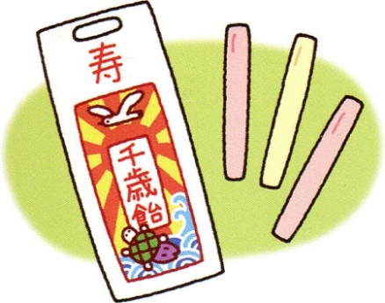
Afterward, the children are photographed with their families. They receive long red-and-white sticks of hard candy called chitose-ame (thousand-years candy). It’s believed that whoever eats the candy will have a thousand years of happiness. Turtles and cranes—symbols of long life—decorate the candy bag. Later, the children have a special dinner to celebrate the long and happy life ahead of them.

Look at these old illustrations below and answer the questions about them.

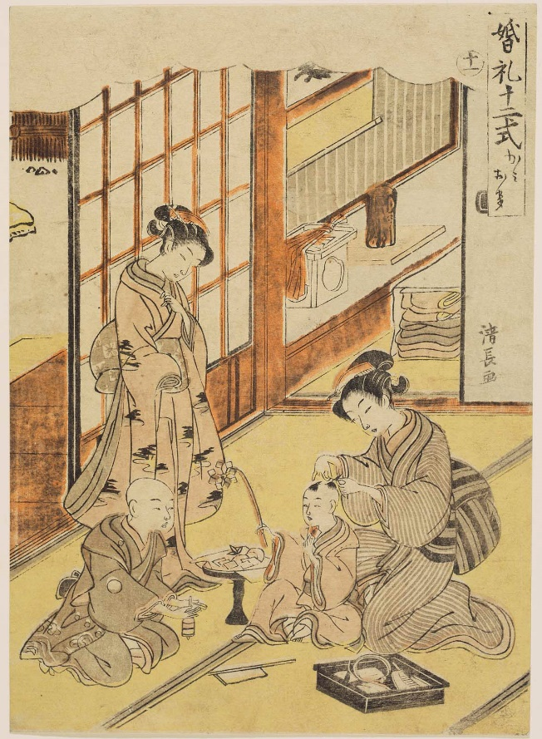
What is the name of this traditional custom?

_________________________________________
How old is the child?

_________________________________________
What is happening in this picture?

_________________________________________

_________________________________________

_________________________________________

Why did they do it?

__________________________________________________________________________________

__________________________________________________________________________________
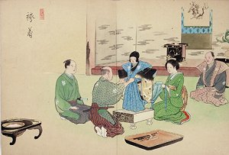
What is the name of this traditional custom?

_______________________________________
How old is the boy?

_______________________________________

What is happening in this ceremony? What would the boy have had on before?

__________________________________________________________________________________

When is Shichi-Go-San celebrated in Japan?

__________________________________________________________________________________

Why are the ages 3, 5 and 7 celebrated? Give two reasons.

- ___________________________________________________________________________

- ___________________________________________________________________________

Complete these sentences with as much information as possible.
- To celebrate Shichi-Go-San, Japanese families go to Shinto shrines and….

_________________________________________________________________________________
- The children dress up in traditional clothes and…

_________________________________________________________________________________
- The children receive bags of…

_________________________________________________________________________________

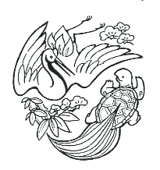
For the Japanese people why are turtles and cranes special?

____________________________________________________

What aspect of Shichi-Go-San do you find most interesting?
Or which part would you enjoy most?

__________________________________________________________________________________

__________________________________________________________________________________

