Scrap Teachers Episode 2 Part 4 Questions and Answers
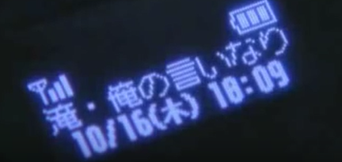
- How much time has lapsed since Takusa sensei received the last message on his mobile.
44mins
- During the fight scene one of the transfer students puts his hair up into a top knot. Why do you think he does this? (Hint: Remember the book he was reading earlier)

He’s the same student that was reading about the way of the samurai earlier in the episode. He’s wanting to look like a samurai.

- There’s lots of ways to say thank you in Japanese depending on how grateful you are and how respectful you’re wanting to be. At the end of the fight scene, Kusaka says thank you twice to the transfer students. Which two versions of “thank you” does he say?

- ありがとう Arigato
- どうもありがとう Domo arigato
- どうもありがとうございます Domo arigato gozaimasu
- ありがとうございます。Arigato gozaimasu

- What makes the girl Oosaki laugh at the end of the episode?

The teacher Takusa sensei says “te” and the hand gesture to his head. It’s the same thing that she did at the beginning of the episode.
=

