Scrap Teachers Episode 2 Part 4 Questions
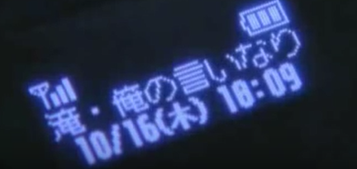
- How much time has lapsed since Takusa sensei received the last message on his mobile.
____________________

- During the fight scene one of the transfer students puts his hair up into a top knot. Why do you think he does this? (Hint: Remember the book he was reading earlier)

_______________________________________________________________

_______________________________________________________________

_______________________________________________________________

- There’s lots of ways to say thank you in Japanese depending on how grateful you are and how respectful you’re wanting to be. At the end of the fight scene, Kusaka says thank you twice to the transfer students. Which two versions of “thank you” does he say?

- ありがとう Arigato
- どうもありがとう Domo arigato
- どうもありがとうございます Domo arigato gozaimasu
- ありがとうございます。Arigato gozaimasu

- What makes the girl Oosaki laugh at the end of the episode?

_____________________________________________________________
_____________________________________________________________
_____________________________________________________________
_____________________________________________________________
- One of the things that helps Takusa sensei know what to do is Sugi sensei’s speech about a teacher’s role being to “warm up a student’s cold heart”. Reflect on your experiences with teachers you’ve had in the past. What have they done that has helped to inspire you to learn, be the best you can be? You don’t need to write the name of the teachers.
____________________________________________________________________
____________________________________________________________________
____________________________________________________________________
____________________________________________________________________

