Scrap Teachers Episode 2 Part 3 Questions and Answers
- During the whole episode the word sensei has been translated as what English word?
Sensei
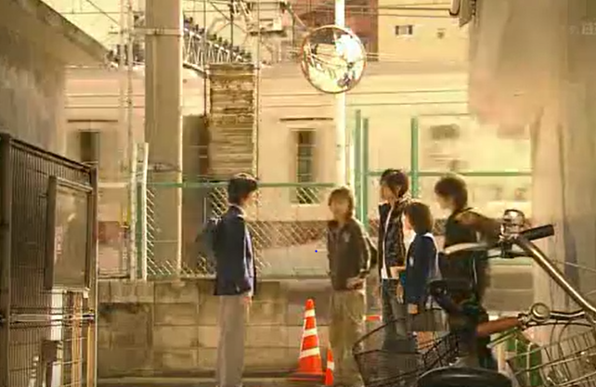
- Why do you think there’s a round mirror above where the students are standing?

So that drivers and pedestrians can see what’s coming around the corner. Japanese streets are very narrow.

- Oosaki used genkoyoshi paper to write her reflection essay. She wrote vertically and therefore the writing starts from the left hand side of the page. Draw an arrow connecting the genkoyoshi rule to an example in the text.

Full stop has its own box |  | Indent one space to start a new paragraph |  | The title begins 3 squares in
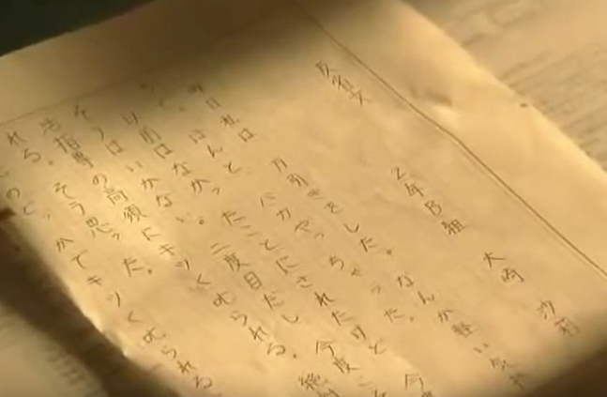
4. What year of Middle School do you think Oosaki is? There’s a clue on the left side of the paper.
Year 2 Class B

- Look at how Oosaki has written the end of her reflection essay.
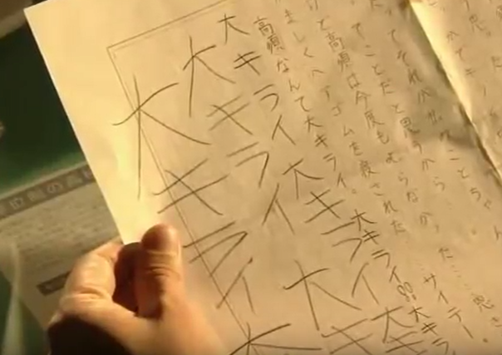
- She’s written the word きらい (hate),
pronounced kirai in katakana instead of
hiragana. Why?
Emphasis
- She’s written the characters outside of the
boxes in a messy kind of way. Why?
She’s angry, it shows the emotion with
which she wrote it
- She’s added the kanji character 大(dai) in front of the word hate. What does dai mean? Look at the kanji page in your books. How would you translate dai-kirai?
It means “big”. Therefore daikirai is “Big hate” – really hate, detest, hate with passion

Scrap Teachers Episode 2 Part 3 Questions and Answers continued…

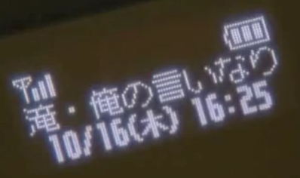
- Apart from the full battery and reception bars, can you find 3 more pieces of information on Takasu’s phone?

Date: 16th October
Day of the Week: Thursday （木）
Time: 4:25pm

- At the end of this part of the episode, Sugi sensei cries out いたい pronounced itai. This means “Ouch!” or “It hurts!”.
Here’s the sentence pattern to explain which part of your body hurts.

Body part が いたい です。
- head b) は tooth c) おなか stomach

Translate the sentences below into Japanese. Don’t leave any spaces between characters.

a) | My head hurts | あ | た | ま | が | い | た | い | で | す | 。

b) | My tooth hurts | は | が | い | た | い | で | す | 。

c) | My stomach hurts | お | な | か | が | い | た | い | で | す | 。

- Sugi sensei got the attention of the bullies by calling out Yankumi. Yankumi is a reference to yakuza, the Japanese mafia. What the clip about 10 interesting yakuza facts and fill in the paragraph below with the appropriate words.
Two distinct ways of telling if someone is mafia is to look at their fingers. If part of their finger has been cut off it means that they have had to apologise for something or they’ve been punished. Yakuza also have many tattoos on their body. The yakuza are members of organised crime “families”. There’s a written exam to be able to become yakuza. Not only are they famous for crime but also for providing relief/help in times of natural disasters. The name yakuza comes from the numbers 8, 9 & 3.

