Scrap Teachers Episode 2 Part 1 Questions and Answers
- One of the transfer students called Yoshida says おおきくなれ、おおきくなれ(Ookiku nare ookikunare). What does it mean?
Grow bigger grow bigger
- What number appears in the signage for the shop?
300 – It’s the price of every thing in the shop (300 yen – approximately 300 yen)
- Did the Deputy Principal Mr Yabuki answer the phone with もしもし(moshi moshi)? Yes
- When the new teacher says he’s going to the shop too does he say the word 行きます(ikimas)?
Yes
- List 3 sponsors of the show.
coca cola, docomo, canon, meiji, Suzuki
- Had Oosaki ever stolen before? Give details.
Yes, a sharpener – the translator who did the subtitles translated this wrong. They said “sharp pen” which is a pacer pencil
- What does ごめんなさい (gomennasai) mean?
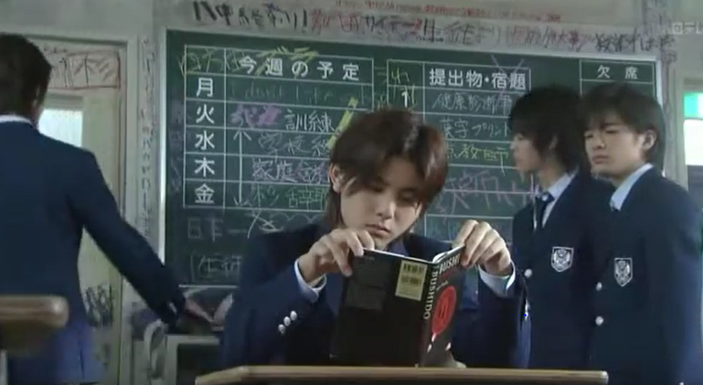
I’m sorry
- Look at the blackboard at the back of the room. What do you think the 5 kanji characters down the left side mean?
Days of the week Monday-Friday

- What is the title of the book that one of the transfer students is reading at his desk?
Bushido (Way of the Samurai)
- What causes the teachers to panic and pause the meeting suddenly?
A teacher’s hair piece falls off while he’s asleep
- What penalty does the transfer student give Oosaki for shoplifting?
She has to write a reflection essay
- You would’ve noticed oosaki hitting her forehead and saying “te” quite a few times in this first part of the episode. It’s basically a way of saying “Woops” in Japanese. Do we do something similar as a gesture in our culture?
We also hit our forehead sometimes, especially if we have forgotten something.

