Scrap Teachers Episode 2 Part 1 Questions
- One of the transfer students called Yoshida says おおきくなれ、おおきくなれ (Ookiku nare ookikunare). What does it mean?

______________________________________________

- What number appears in the signage for the shop? ____________________

- Did the Deputy Principal Mr Yabuki answer the phone with もしもし(moshi moshi)?
______________
- When the new teacher says he’s going to the shop does he say the word 行きます(ikimas)?
______________

- List 3 sponsors of the show. ______________ ______________ ______________

- Had Oosaki ever stolen before? Give details.

____________________________________________________________________

- What does ごめんなさい (gomennasai) mean? ____________________________
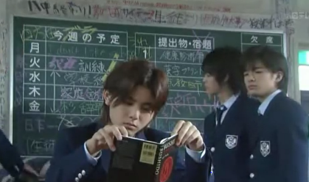
- Look at the blackboard at the back of the room. What do you think the 5 kanji characters down the left side mean?
______________________________________
- What is the title of the book that one of the transfer students is reading at his desk?

_______________________________

- What causes the teachers to panic and pause the meeting suddenly?

_____________________________________________________________________

- What penalty does the transfer student give Oosaki for shoplifting?

_____________________________________________________________________

- You would’ve noticed Oosaki hitting her forehead and saying “te” quite a few times in this first part of the episode. It’s basically a way of saying “Woops” in Japanese.
Do we do something similar as a gesture in our culture?

_____________________________________________________________________

