むずかしい
difficult

つまらない
boring
たのしい
enjoyable
かんたん
easy

です。

は
かもく
subject
一番
The most

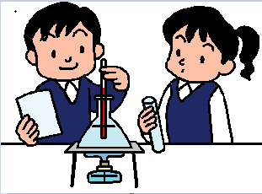

おもしろい
interesting

好きな
likeable

好きじゃない
not likeable

上手
Skilful/good at

下手
Not skilful/bad at
not likeable

一番 むずかしい かもく は すう学 です。The most difficult subject is Maths.
一番 好きな かもく は 日本語 です。The most likeable (My favourite) subject is Japanese.

Describing subjects

は
Describing word
です。
おもしろい
interesting

たのしい
enjoyable

つまらない
boring

むずかしい
difficult

かんたん
easy

が
Describing word
です。
好きな
likeable

好きじゃない
not likeable

上手
Skilful/good at

下手
Not skilful/bad at
not likeable

です。

は
一時間目
Lesson 1

の
月よう日
Monday
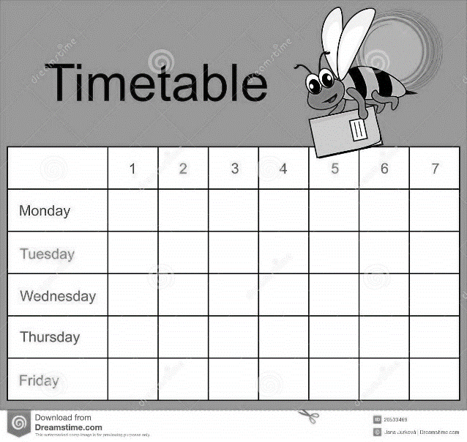
Examples:
月よう日 の 一時間目 は 何 ですか。 What is Monday Lesson 1?

木よう日 の 三時間目 は 英語 です。 Thursday Lesson 3 is English.

七時間目
Lesson 7

六時間目
Lesson 6

五時間目
Lesson 5

四時間目
Lesson 4

三時間目
Lesson 3

二時間目
Lesson 2

金よう日
Friday

木よう日
Thursday
水よう日
Wednesday
火よう日
Tuesday

