Pets
ペット が いますか。 Do you have a pet?
＿＿＿＿が います。 I have a ______.
＿＿＿＿と＿＿＿＿が います。 I have a ___ and ___.
ペットが いません。 I don't have a pet.
でも、＿＿＿が ほしいです。 But I want a ____.
If you want to say how many you have of a pet.
＿＿＿＿が counter います。

To describe a pet.

（＿＿＿＿は）describing word です。

Pets | Counters | Describing Words
とり bird  ねこ cat  いぬ dog  うま horse  きんぎょ goldfish  うさぎ rabbit  かめ turtle  へび snake  あひる duck  にわとり chicken  ねずみ mouse  とかげ lizard  モルモット guinea pig | 一匹 （いっぴき）  二匹 （にひき）  三匹 （さんびき）  四匹 （よんひき）  五匹 （ごひき）  六匹 （ろっぴき）  七匹 （ななひき）  八匹 （はっぴき）  九匹 （きゅうひき）  十匹 （じゅっぴき） | かわいい cute  うるさい noisy  こわい scary  ちいさい small  おおきい big

Read what these people are saying about their pets and answer the questions below.
- What animal is in the box according to the boy?
______________

- Which two animals are described as being cute according to their owners?
いぬとねこがいます。
いぬはちいさいです。
ねこはかわいいです。
______________ and _____________

- How does the girl in the skirt describe her dog?
______________
かめがいます。
かわいいです。
いぬがいます。
おおきいです。

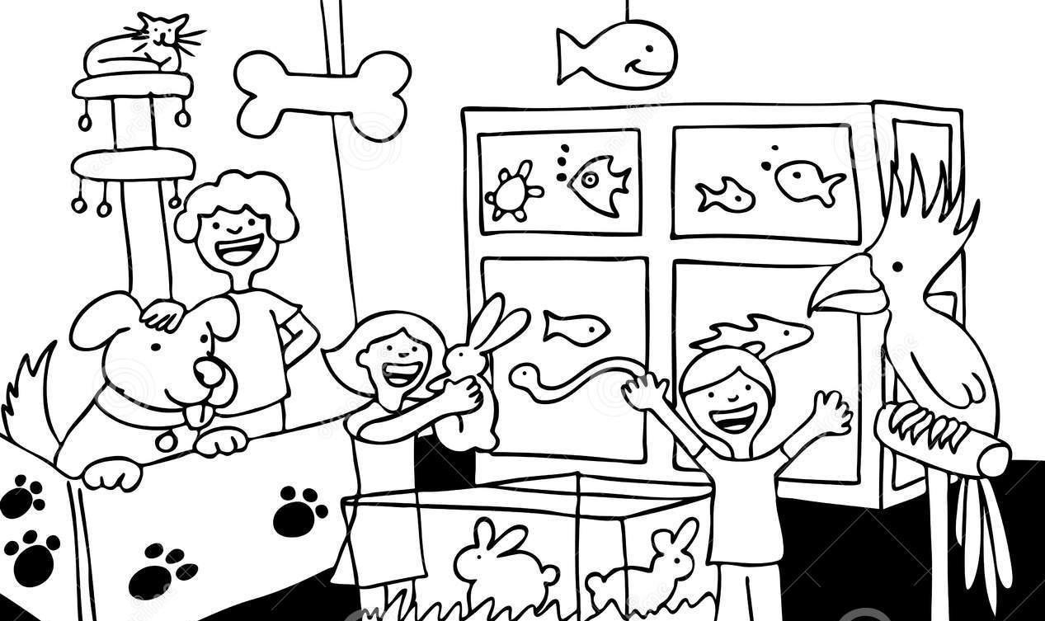
Look at the picture of the pet shop opposite.
The owner is being interviewed about how many animals she has for sale. Translate the following into Japanese.
I have a bird.

I have a cat and a dog.

I have 3 rabbits.

I have 5 fish.
さ | か | な

