Colour in and cut out each of these elements of a Japanese meal.
The main dish, soup, rice, salad/veg, and chopsticks.
Then glue each element in the correct place on the place mat.
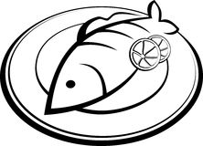
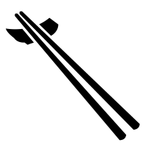
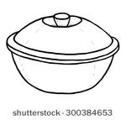
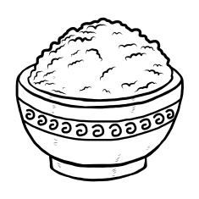
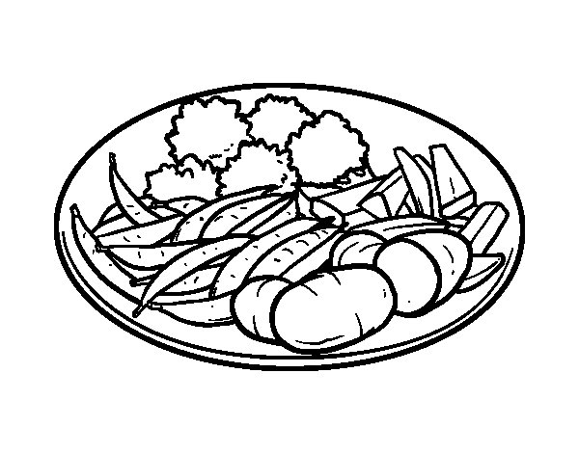

Japanese Table Setting
- Rice bowl is placed in the lower left corner of the place setting.
- Soup bowl is place in the lower right corner of the place setting.
- The main meal is placed in the middle of the place setting towards the right side.
- The salad/vegetables are placed in the upper left corner above the rice bowl.
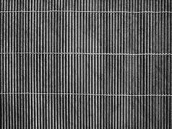
- The chopsticks are placed at the bottom of the place setting close to the edge of the table. The tips of the chopsticks point to the left.

