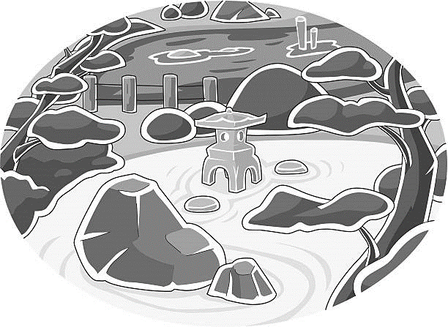
Japanese Garden Design Project
For this project you will put into practice the Design Cycle elements that you learnt about in Digital Tech lessons. Our Design Cycle for this project looks like this.

Plan | Design | Implement | Evaluate
What are you making?  What are the conditions?  When should it be done? | Research  Brainstorm ideas  What materials will you use?  What tools will you use? | This is the creating and making process. | Have you achieved what you wanted?  What could be added?  What could be removed?
Plan
You have been given the opportunity to compete in a Japanese Garden design competition.
For this competition you are required to present the judges with a model of your Japanese garden design.
You will be provided with a box in which your garden model must be confined.
There are various resources in the class room that you can use to create your garden. These include:
- Modelling clay – dries overnight
- Paint – black, red, brown
- Pop sticks – red, green, and natural wood colour
- Felt – green and blue
- Cardboard – all colours
- Paper – various colours
- Fabric material
- Foam moss balls
- Glue
- Blue tak
- Sticky tape
- Crepe paper - pink
You might have items at home that you’d also like to use.
You will have one lesson a week from Week 3 – 7 to design and create your garden.
Gardens will need to be submitted in time for a Garden Show in Week 8.
You will work in groups of up to 3 people. Each member of the team has to be engaged with the task and contributing to at least one or more elements of the garden.

Design – Research/Brainstorm

We will spend a lesson in Week 2 researching Japanese gardens. And finding out the types of elements that can be found in a Japanese garden.
In the second part of the lesson you will have time to start designing your garden.
Let’s start with a brainstorm first of some typical elements of a Japanese garden:
Things you might find in a Japanese garden:

List the elements that your group would like to include in your garden design. (Remember you need at least 4).
Element | Materials you might use to make it

Design - Blueprint/Diagram
Sketch some maps to brainstorm how you want your garden to look. Check that all your elements appear.

For example:
torii gate
rock garden
stepping stones
bamboo fencing
bridge
lake

Implement

Week | What?  What do you want to accomplish this lesson?  What element will you make? | How?  What resources will you need? | Who?  Who will do what?
3
4
5
6
Evaluate

Write an evaluation report answering the following questions.

- Has your design fulfilled all of the elements required?
- What is your favourite part about your garden design and why?
- What part/s of the process did you find most challenging?
- If you could change something about your design what would you change/fix?

Your report should be about 150 - 200 words (including questions).
Due: end of Week 8.

