Japanese Food Cross Word
Clues

Across
4. raw fish

6. crumbed pork or chicken

Down
1. Japanese people use these to eat

2. chicken skewers

3. Something included in most
Japanese meals

4. What you put on your hands
when making rice balls

5. thick wheat noodles

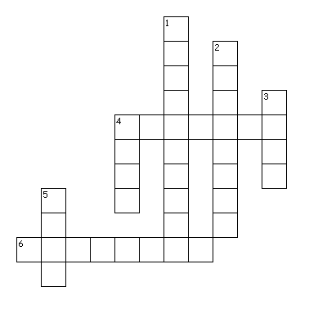

て | い | っ | ら | し | ゃ | い | ま | せ | う
あ | ん | い | と | り | か | ら | あ | げ | ど
は | し | ぷ | う | い | す | え | お | い | ん
か | く | さ | ら | た | し | け | さ | す | つ
さ | し | み | し | だ | こ | だ | て | り | ご
き | ち | り | よ | き | く | れ | と | ち | せ
と | ん | か | つ | ま | さ | き | そ | ふ | ん
や | ぬ | む | な | す | や | う | と | ど | は
か | す | き | や | き | さ | ひ | つ | ほ | そ
ら | き | た | ゆ | ま | に | か | る | へ | ら
Japanese Food Word Find

Katusudon
Tonkatsu
Sushi

Sashimi
Tempura
Yakitori
Torikaraage
Sukiyaki
Udon
Kudasai (Please)
Itadakimasu (Thankyou, I’m about to eat)

Gochisousama (Thank you for the meal)
Irasshaimase (Welcome to the shop/restaurant)
Hashi (chopsticks)

