Japanese Baths
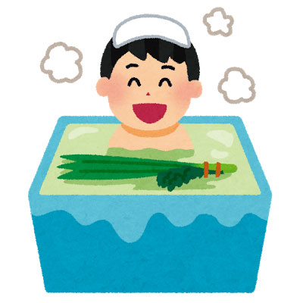
In Japan the main purpose of taking a bath, besides cleaning your body, is relaxation at the end of the day. The typical Japanese bathroom consists of two rooms, an entrance room where you undress and which is equipped with a sink, and the actual bathroom which is equipped with a shower and a deep bath tub. The toilet is almost always located in an entirely separate room.
When bathing Japanese style, you are supposed to first rinse your body outside the bath tub with the shower or a washbowl. Afterwards, you enter the tub, which is used for soaking only. The bath water tends to be relatively hot, typically between 40 and 43 degrees.
After soaking, leave the tub and clean your body with soap. Make sure that no soap gets into the bathing water. Once you finished cleaning and have rinsed all the soap off your body, enter the bath tub once more for a final soaking. After leaving the tub, the water is usually left for the next member of the house. It is to keep the bath water clean for all members of the house that washing and rinsing is done outside of the actual bathtub.
Modern bath tubs can be programmed to be automatically filled with water of a given temperature at a given time, or to heat up the water to a preferred temperature.

Watch the clip about a girl giving the reasons why Japanese Baths are good. As you watch decide which of the statements below are true (T) and which are false. Put either a T or F in the box next to each statement.
Bathrooms have built in dryers for drying the laundry.
You can sit down to shower/wash your body.
The water in the bath stays hot.
You don’t have to change the water for the next person.
More than one person at a time can use the bathroom.
There’s a call button for help.
There’s a built in sink on top of the toilet.
There’s a shower hose in the sink.
You can turn the bath on from the kitchen.
The bath water can be used to wash clothes
Water can be sprayed all around the bathroom
You bathe in clean hot water after you clean your body.

