Japanese Art Word Search

Y | V | D | Z | A | F | G | B | S | U | Q | E | T | C | F | S | O | E | J | K
P | A | V | R | P | K | S | O | B | W | H | S | Y | D | K | O | Z | S | C | R
O | V | L | I | A | C | L | N | H | I | O | W | O | O | C | E | X | O | W | E
K | P | H | P | E | N | V | Z | F | K | L | H | E | D | Y | F | L | L | X | U
E | O | M | U | S | K | S | A | U | C | Q | Q | S | B | B | B | Z | M | Y | O
M | X | A | H | I | O | A | I | V | Y | X | G | L | E | D | Q | A | Z | D | X
O | Q | M | A | G | P | C | R | I | H | C | O | M | O | M | S | T | N | Q | H
N | D | N | A | T | U | R | E | A | O | Z | O | O | R | C | A | E | Q | S | C
V | E | H | J | N | R | O | K | O | T | W | W | O | O | M | T | G | Z | B | N
X | O | M | Y | F | G | N | A | Y | I | E | B | T | X | N | K | C | F | M | O
O | T | N | I | H | S | A | B | R | H | O | S | R | I | Q | E | J | K | S | V
K | S | I | O | W | N | S | U | V | T | P | X | N | Y | G | Y | U | B | V | D
M | U | E | C | U | E | H | K | S | B | F | A | Z | Z | B | P | U | U | K | G
K | T | A | F | N | M | Z | I | Y | O | P | N | R | U | K | D | J | P | R | O
J | R | H | I | F | A | N | I | N | J | A | Z | Y | G | D | T | S | J | X | D
P | G | R | M | H | X | H | I | V | U | U | S | J | H | I | B | Y | P | E | Z
A | H | D | S | V | Q | S | A | M | U | R | A | I | Z | R | L | L | R | L | I
S | U | I | W | T | L | K | A | A | A | M | S | H | A | O | D | L | G | H | L
Y | E | A | W | P | V | G | X | P | C | M | Z | G | W | M | N | T | A | F | L
G | A | T | E | M | P | L | E | S | E | N | A | R | C | B | A | A | U | C | A

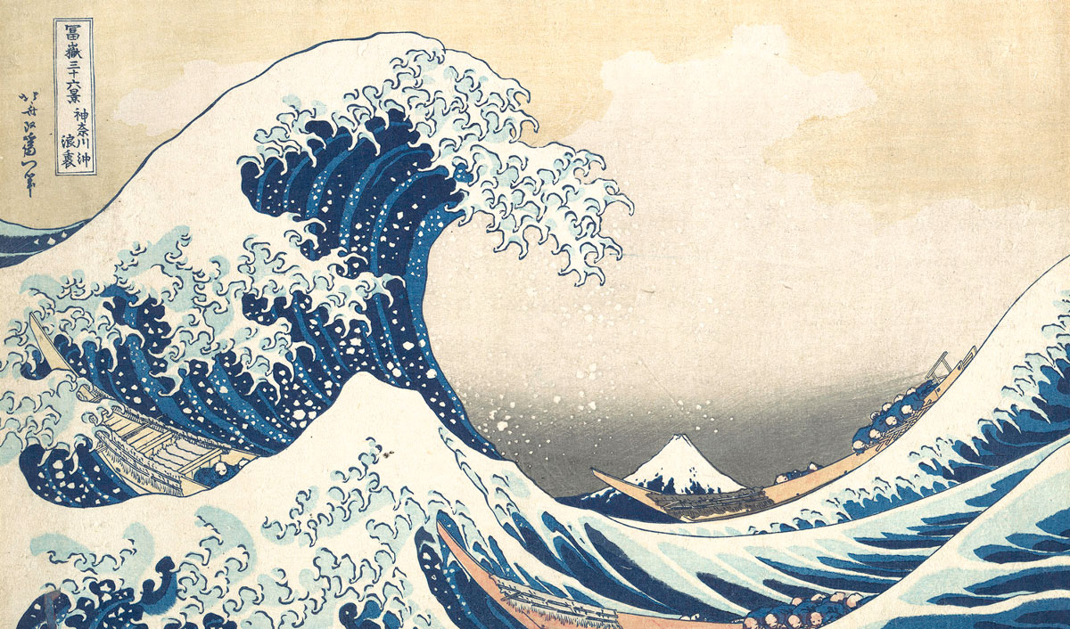
BONZAI BUDDHISM CALLIGRAPHY
CARP COSPLAY CRANE
GAMESHOWS GEISHA GODZILLA
KABUKI KARATE MANGA
MASCOTS MOCHI NATURE
NINJA NINTENDO POKEMON
ROBOTS SAMURAI SHINTO
SHRINES SUMO TEMPLES
WOODBLOCK

