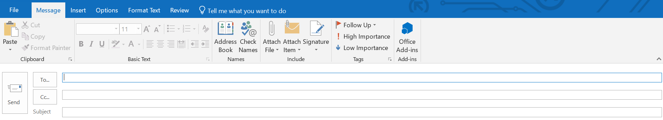

Type your email here…

Type the name of your friend here

Some Japanese Cultural Advice for you