How do Japanese students feel about the cleaning their own school rooms and toilets?
(Source: https://www.quora.com/How-do-Japanese-students-feel-about-the-cleaning-their-own-school-rooms-and-toilets)
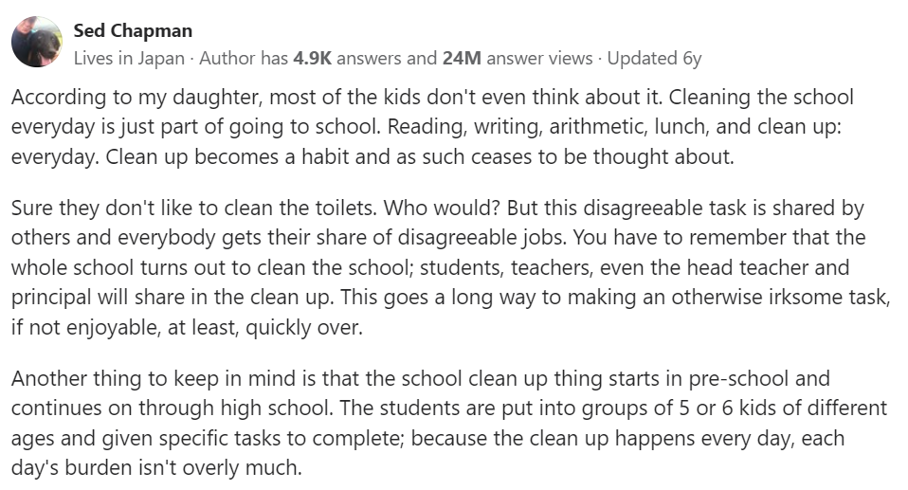

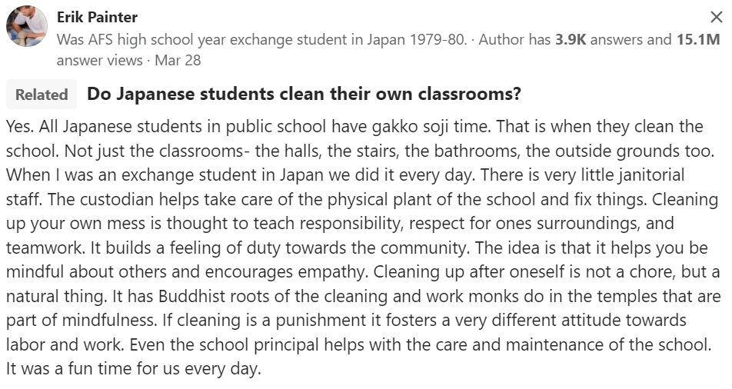
How do Japanese students feel about the cleaning their own school rooms and toilets?
(Source: https://www.quora.com/How-do-Japanese-students-feel-about-the-cleaning-their-own-school-rooms-and-toilets)

