Match the humble and honorific terms for family members.

そふ・  あね・  ちち・  いもうと・  そぼ・  はは・  あに・  おとうと・ |  | ・おばあさん  ・おとうとさん  ・おにいさん  ・おかあさん  ・おとうさん  ・おじいさん  ・おねえさん  ・いもうとさん

Write the appropriate family member word in Japanese next to these scenarios.

- You’re calling out to your dad who is out in the shed. _____________________

- You’re telling your teacher that your mum is sick. _____________________

- You’re writing a letter to your grandma _____________________

- You’re telling your little sister to stop annoying you. _____________________

- You’re telling a friend that you’re visiting your grandma. _____________________

- You’re little brother is calling out to you. _____________________

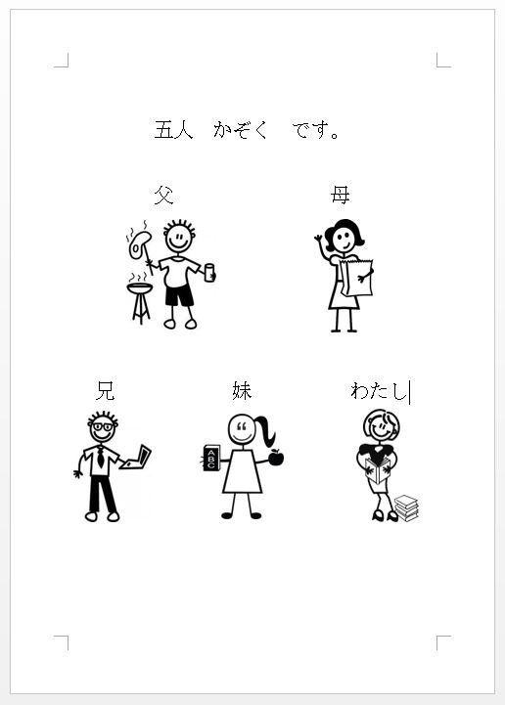

Family Poster

Using “car sticker” images, create a family poster of either your family or a family of your choice.

Write a sentence saying how many people are in the family.

Label the family members in Japanese too.

You will need to print off the page with the pictures and then write the sentence and labels by hand.

