Body Parts and Colours Sentences

|  |  |  |  |
| --- | --- | --- | --- |
| Body part | が | Colour | です。 |

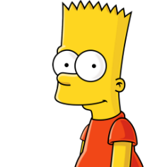

For example:

かみのけ　が　きいいろ　です。

He has yellow hair.

Write a sentence for each of these indicated body parts.

|  |  |
| --- | --- |
| http://yorktownsentry.com/wp-content/uploads/2014/12/15632775_s_zps7f87f857.jpg(nose) |  |
| http://images.clipartpanda.com/cookie-monster-clip-art-cookie_monster_by_neorame-d4yb0b5.png  (head) |  |
| http://upload.wikimedia.org/wikipedia/en/6/67/Minnie_Mouse.png  (hands) |  |
| http://upload.wikimedia.org/wikipedia/en/7/73/Shrekcharacter.jpg  (body) |  |
| http://www.disneyclips.com/imagesnewb6/imageslwrakr01/febr226.gif  (legs) |  |
| http://th03.deviantart.net/fs71/PRE/i/2013/296/7/5/pluto_the_dog_by_awesomephoenix-d6rl4m5.jpg(ears) |  |