ア | デ | レ | ― | ド | に | よ | う | こ | そ | ！
Welcome to Adelaide
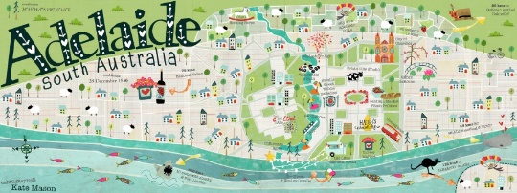
Your task is to create an A4 pamphlet for Japanese tourists. Your pamphlet needs to include a description of at least 3 attractions.

Attractions/Places in Adelaide |  |  | Adjectives (なtype adjectives are shaded)
はくぶつかん | Museum |  | 小さい | Small
どうぶつえん | Zoo |  | 大きい | Big
きょうかい | Church |  | ふるい | Old
こうえん | Park |  | あたらしい | New
かわ | River |  | うつくしい | Beautiful
うみ | Beach |  | たのしい | Fun/Enjoyable
モール | Mall |  | おもしろい | Interesting
ビーチハウス | Beach House |  | しずか | Quiet
デパート | Department stores |  | きれい | Pretty/clean
 |  |  | ゆうめい | Famous
 |  |  | にぎやか | Noisy, busy, bustling
Choose 3 attractions/places and at least 1 adjective for each. Write them in English in this table.

 | １ | ２ | ３
Place

Adjective

Sentence Structures
Use these sentences to write a description about each of your 3 places.

Option 1
place | が | あ | り | ま | す | 。
There is a ＿＿＿＿.
adjective | で | す | 。
It’s ＿＿＿＿＿＿.

Option 2
なadjective | な | place | が | あ | り | ま | す | 。
いadjective | place | が | あ | り | ま | す | 。
There is a ＿＿＿＿＿ ＿＿＿＿＿.

